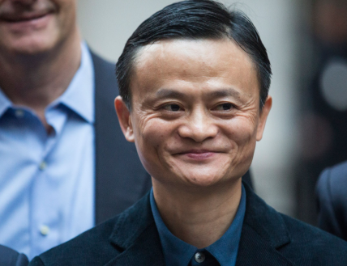 | 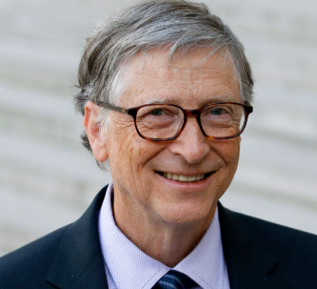 | 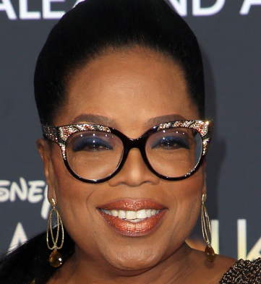 | 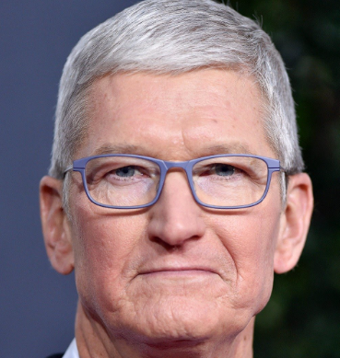 | 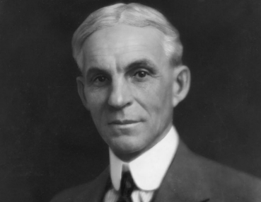 | 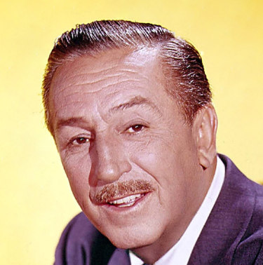
1 | 2 | 3 | 4 | 5 | 6
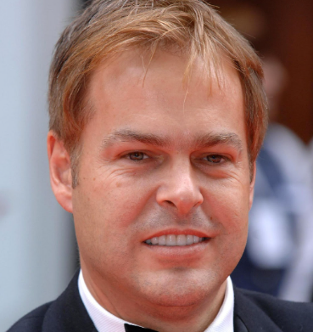 | 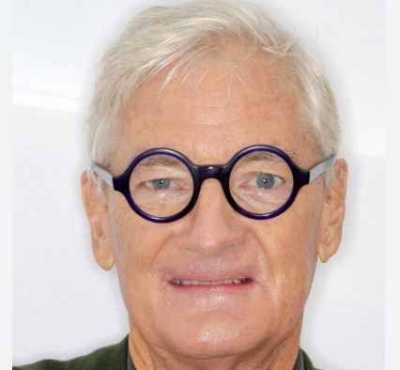 | 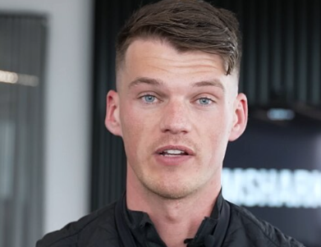 | 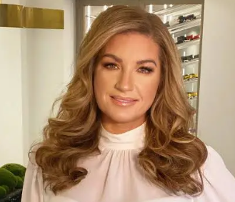 | 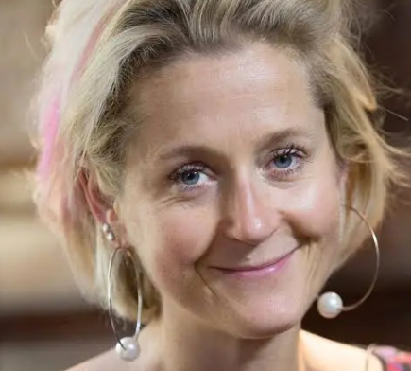 | 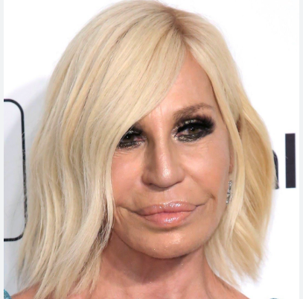
7 | 8 | 9 | 10 | 11 | 12
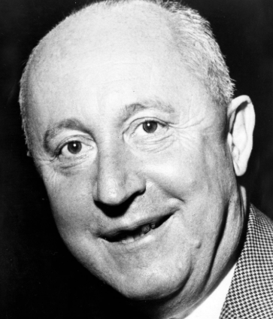 | 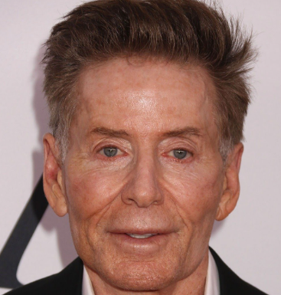 | 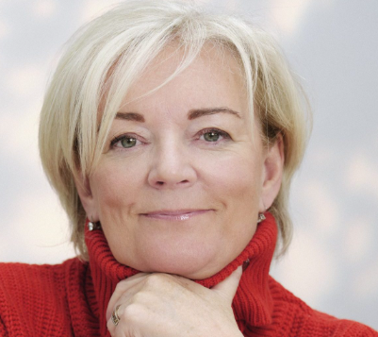 | 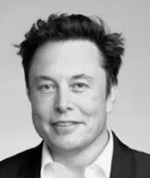 |  | 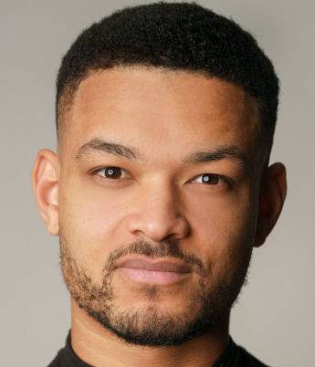
13 | 14 | 15 | 16 | 17 | 18


1 mark for the person and 1 mark for the business. Total marks 36.

1 Jack Ma (Alibaba) | 2 Bill Gates (Microsoft) | 3 Oprah Winfrey (Harpo productions) | 4 Tim Cook (Current CEO of Apple) | 5 Henry Ford (Ford Motor Company) | 6 Walt Disney (Disney)
7 Peter Jones (Dragons’ Den) | 8 James Dyson (Dyson) | 9 Ben Francis (Gymshark) | 10 Karen Brady (Birmingham FC / West Ham FC) | 11 Martha Lane Fox (Lastminute.com) | 12 Donatella Versace (Versace)
13 Christian Dior (Dior) | 14 Calvin Klein (Calvin Klein) | 15Jo Malone (Jo Malone) | 16 Elon Musk (Tesla) | 17 Mark Zuckerberg (Meta / Facebook) | 18 Steven Bartlett (Dragons’ Den)
Notes: These are the businesses or programs they might be known for. Accept other correct answers. E.g. Elon Musk SpaceX

