Instructions: Start with the STARTER sentence then choose 3 more sentences and put them in the right order to answer the question. If you are working in a pair there are two possible answers – can you get them both?
STARTER:
Having a post-sales service would be important to a business because…

this allows customers to resolve any problems they may have with the product (1)

Therefore, customer loyalty should increase (1)

So now the business should gain repeat purchases (1)

this could give the business a USP (1)
This is because the customer now feels that the business is looking after them once they have purchased the product (1)
Therefore, the business could gain a strong brand image for customer care (1)
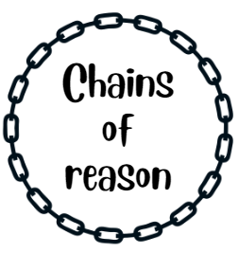

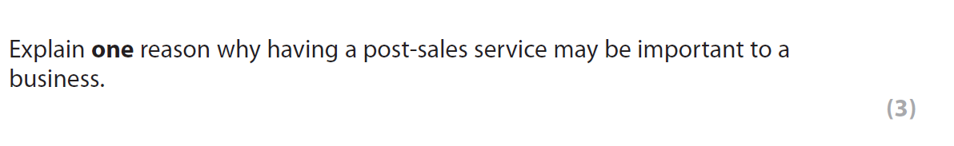

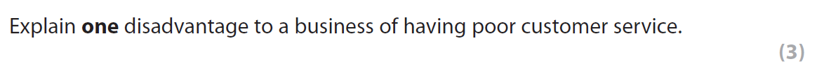

Instructions: Start with the STARTER sentence then choose 3 more sentences and put them in the right order to answer the question. If you are working in a pair there are two possible answers – can you get them both?
STARTER:
One disadvantage to a business of having poor customer service is…

that customers may become dissatisfied with the business (1)
As a result, they may not make any repeat purchases (1)
Therefore, the market share of the business may fall (1)

that the brand may be damaged (1)
Therefore, the business cannot charge a premium price (1)
As a result, profit margins may fall (1)

Note to teachers
Answers – they are in the correct order. There are two possible chains on each page, works well as a pairs activity.
You could cut these up and pairs try and work out the two chains or ask students to write a 3 mark answer using these as a guide.
Edexcel GCSE Business 1.2.4 but could be used for other boards.

