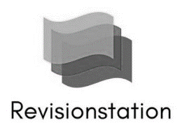
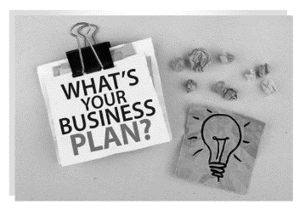
GCSE Business
Business Plan Activity Sheet

Scenario: You are an entrepreneur and you have decided to take a risk on a business in the hope of a reward. You can choose: either a clothes shop, a café, a barbers or hairdressing business.
- Decide what the name of your new business will be, it needs to be something very unique

- Design a logo for your new business using the name you have chosen

- Get some lined paper and write business plan as the title at the top, add your name

- Create a business plan for your business.
  - Write a paragraph introducing your business, explain:
    - Where the location of your business will be
    - What staff will you need
    - Who will be your customers (your target audience)
  - Write a second paragraph about your marketing mix, explain:
    - What products or services will you sell
    - What prices will you charge
    - If you will have a website or be based in premises or both
    - What promotions you will offer (e.g. two for one, 50% off etc.)

- Include a spider diagram explaining who all the stakeholders are in your business and what their objectives might be
  - Customers – low prices and quality products
  - Suppliers – contracts and payment on time
  - Managers – bonuses and meeting targets
  - Employees – job security and promotion prospects
  - Government – taxes and laws
  - Local Community – jobs and no pollution

- Finally add a paragraph explaining what type of business you would like to be, for example; sole trader, partnership, Ltd and your reasons why (discuss liability and other advantages)

