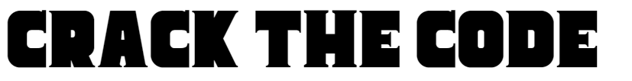

Name _______________________________________________________________ Unit: 1.4.1

L____ ____ ____ ____ ____ ____ ____ ____ | This can be limited or unlimited
O____ ____ ____ ____ | This is the person that starts the business
S ____ ____ ____ ____ ____ ____ ____ ____ | This is the form of business
P ____ ____ ____ ____ ____ | A sole trader can keep all of this and does not have to share it with anyone
S ____ ____ ____ ____ ____ ____ ____ | A private limited company will give the owner financial _____________________
F ____ ____ ____ ____ ____ ____ ____ ____ | This type of business is sold by a franchisor and will give the owner a brand name and lots of support
S ____ ____ ____ ____ ____ | In a Ltd company these can be sold to friends and family
F ____ ____ ____ ____ ____ ____ | This might be easier to raise of the business has the structure of a LTD it will be seen as less risky by the banks

Answers
LIABILITY
OWNER
STRUCTURE
PROFIT
SECURITY
FRANCHISE
SHARES
FINANCE

