Instructions: Student X has written the answer to a question. Rewrite the sentences correcting the mistakes.

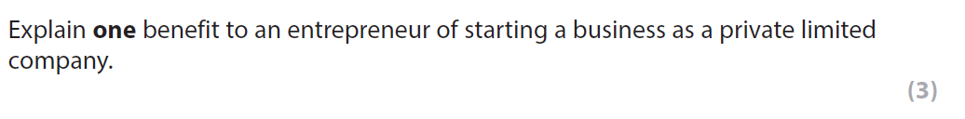
One drawback is a lack of financial security for the entrepreneur because unlimited liability means that personal possessions cannot be lost if the business becomes insolvent.
______________________________________________________________________________________________________________________________________________________________________________________________________________________________________________________
As a result the entrepreneur will be willing to take rewards in order to grow the business.
____________________________________________________________________________________________________________________________________________________________________
One benefit is the ability to make a loss by selling shares on the stock market which means the business may be able to invest in its facilities.
____________________________________________________________________________________________________________________________________________________________________
As a result the business will not be able to expand further and increase costs.
____________________________________________________________________________________________________________________________________________________________________

Correct answer is:

