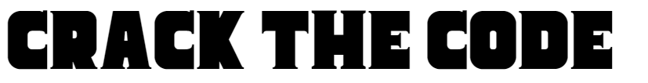
Name _______________________________________________________________ Unit: 1.3.1

A ____ ____ | A long term goal that a business wants to achieve
O____ ____ ____ ____ ____ ____ ____ ____ | More specific measureable goals of a business
S ____ ____ ____ ____ ____ ____ ____ | Start-up businesses will have this goal, to have enough sales to cover costs and still be trading
P ____ ____ ____ ____ ____ | When revenue is greater than costs
S ____ ____ ____ ____ | The best business goals are this (hint: it’s an acronym)
S ____ ____ ____ ____ ____ | When the business goals are to help the planet or community in some way
M____ ____ ____ ____ ____  S____ ____ ____ ____ | The percentage (%) of the total industry sales that the business has
C ____ ____ ____ ____ ____ ____ | The non-financial aim that a business owner might have

Answers
AIM
OBJECTIVE
SURVIVAL
PROFIT
SMART
SOCIAL
MARKET SHARE
CONTROL

