GCSE Business mixed starter quiz
Name______________________________________

- How many people can be in a partnership? _____________________(1)

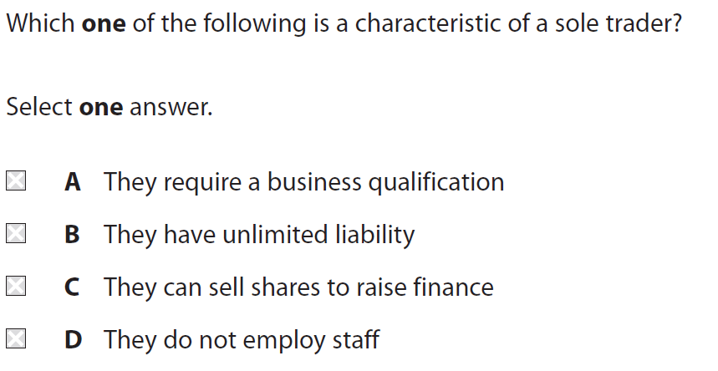

- Give an example of a partnership business _________________________(1)
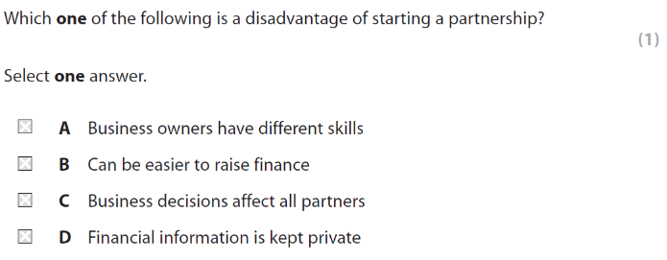

- Who can a private limited company ONLY sell shares to?

_________________________________________________________________(1)

- Give an example of a Franchise business __________________________(1)

- Why is it a disadvantage to a sole trader of having unlimited liability? (2)

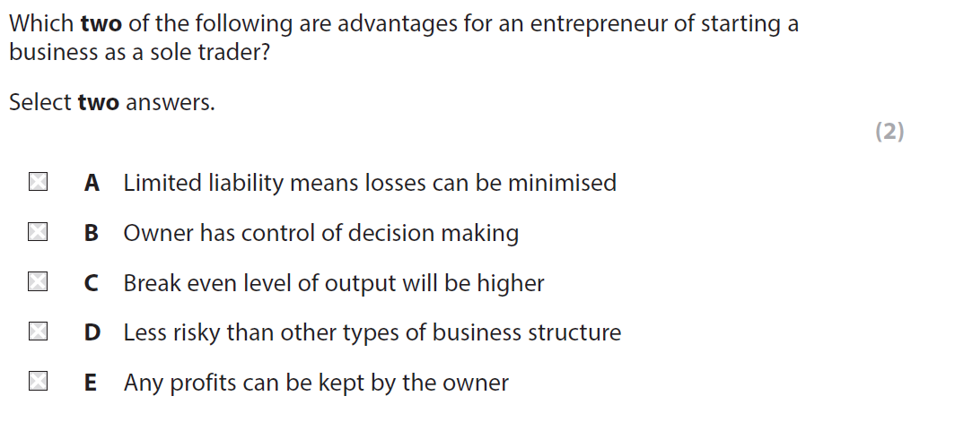

- Name one benefit to an entrepreneur of starting a business as a private limited company _____________________________________________________________________(1)

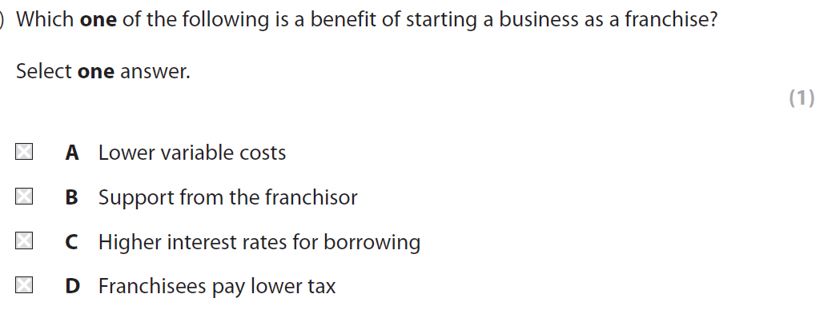

- How many owners are there in a sole trader business?
_________________________________________(1)
- Give an example of a sole trader business ___________________________________________(1)
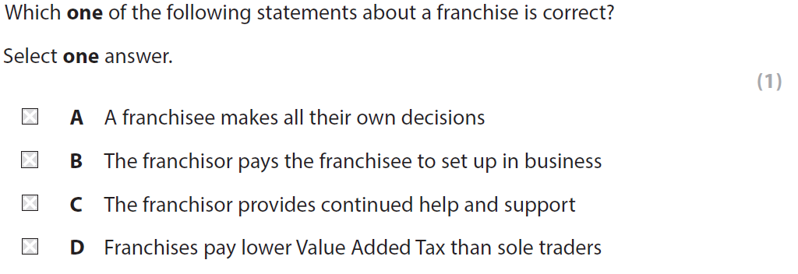
Score
/15

