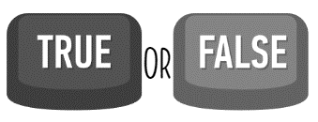Name _________________________________________ Unit _______________________________
Instructions: Can you identify which of these statements is true and which is false? Tick the correct boxes

2.

TRUE FALSE
3.

TRUE FALSE

TRUE FALSE

6.

TRUE FALSE
5.

TRUE FALSE
4.

TRUE FALSE

