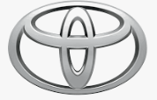 | 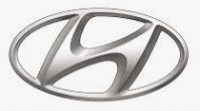 | 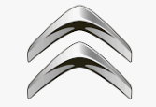 | 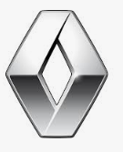
A | B | C | D
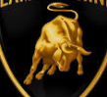 | 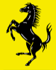 |  | 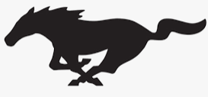
E | F | G | H
 | 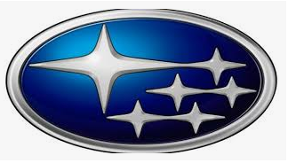 | 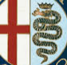 | 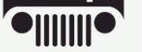
I | J | K | L
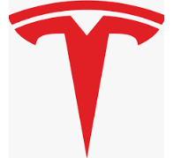 | 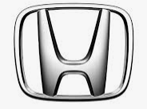 | 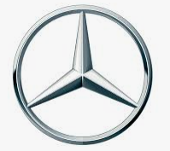
M | N | O | P
Name the brand and for an extra point the company, that currently owns the brand…
Bonus question:

Answers (as of Aug 2022)
A Toyota (Toyota Group)
B Hyundai (Hyundai motor group)
C Citroen (Stellantis)
D Renault (Group Renault)
E Lamborghini (owned by VW group)
F Ferrari (owned by the Agnelli Family)
G Skoda (owned by VW Group)
H Mustang (Owned by Ford)
I Maserati (owned by Fiat Chrysler Automobiles)
J Subaru (Subaru Corporation)
K Alfa Romeo (Owned by Fiat Chrysler Automobiles)
L Jeep (owned by Fiat Chrysler Automobiles)
M Tesla (Tesla Motors)
N Honda (Honda Motor Group)
O Mercedes (owned by Daimler AG)
P BMW (BMW Group)
Bonus: Bugatti (owned by VW group)

